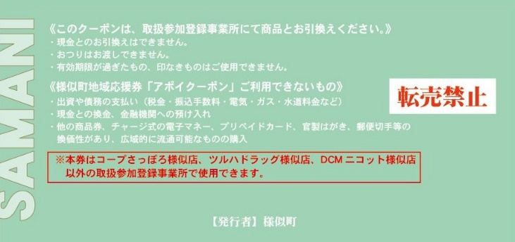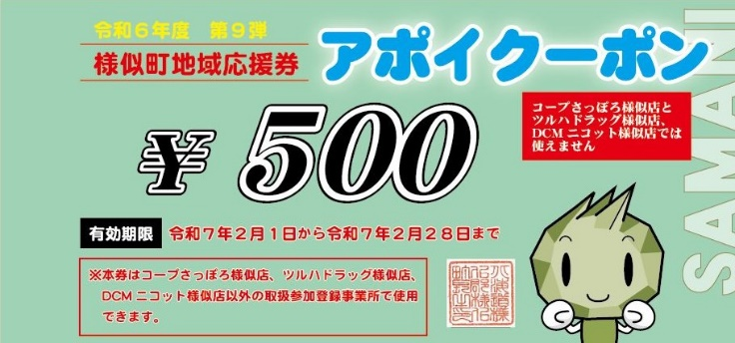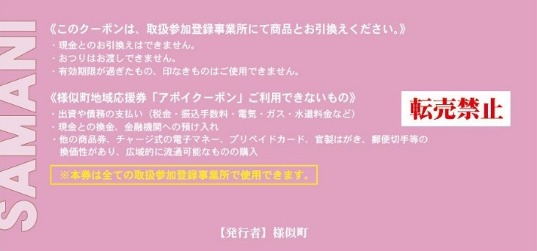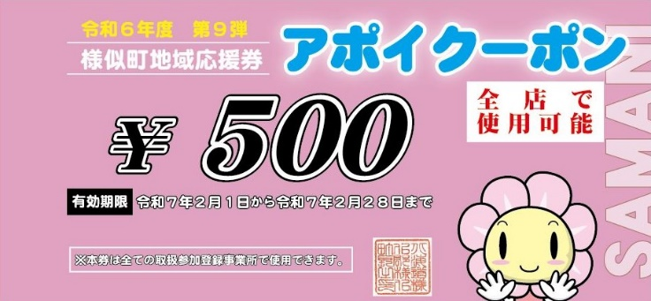

Resale is prohibited.

Effective Date:　Feb 1, 2025 – Feb 28, 2025

Lists the excluded shops

Exceptions are listed on the back

Redeemable at all locations

This coupon can be redeemed at all locations, excluding COOP Sapporo, DCM Nicot, and Tsuruha Drug stores.

2. Use the green coupons at participating locations, excluding the larger brand-name stores. →　１２ Total

There are 2 types of coupons, each valued at 500 yen.

1. Use the pink coupons at all participating locations. →　8 Total

This coupon can be redeemed at any of the participating locations listed on the attached flyer.

**Redeeming Apoi Coupons**